SparkLink Alliance Technical Document Management Regulations

- General Provisions
- In this document, "technical documents" refer to white papers, technical analysis reports, performance evaluation reports, and other relevant documents drafted and published by the SparkLink Alliance (the “Alliance”) in accordance with the SparkLink Alliance Charter (the “Charter”) and observing the procedure stipulated herein.
- The Alliance's technical documents mainly address the development, design, test certification, and marketing of SparkLink short-range wireless communications technology and related products. The Alliance encourages its members to proactively engage in technical documentation activities.
- Guidelines for drafting technical documents for the Alliance:
- Draft documents in line with market needs or in response to the pain points of the short-range wireless communications industry. Use the latest technological innovations to address industry challenges and meet diversified market needs. Transform scientific and technological achievements into commercial applications to fast-track the industry and build an ecosystem.
- Ensure extensive participation and a transparent process.
- Draw on the Alliance's strengths in technical innovation and focus on emerging technology fields.

- Organizational Structure and Responsibilities
- The SparkLink Alliance Council (the Council) is the highest decision-making body for the technical documentation work. The Council shall formulate a technical documentation plan based on key annual tasks or specific requirements of the Alliance, control the direction of documentation work, review and publish the technical documents.
- The SparkLink Alliance Expert Committee (the Expert Committee) shall provide technical consultation and review for technical documentation activities. The Expert Committee may propose a plan for preparing technical documents based on key annual tasks or specific requirements of the Alliance, and provide professional suggestions on the direction and content of technical documentation work.
- The SparkLink Alliance Secretariat (the Secretariat) shall implement the technical documentation plan formulated by the Council and Expert Committee (the Plan). The Secretariat shall promote efforts from all Alliance members or entrust a working group of the Alliance to set up a Task Force, which will in turn draft required technical documents according to the Plan. The Secretariat shall review the scope of technical documents to ensure that these are drafted in line with the Plan.
- The Task Force shall initiate technical documentation, schedule technical documentation activities, and draft technical documents according to the Plan. In addition, it shall ensure that the content of technical documents is reasonable, complete, and well-researched based on the latest trends.

- Procedure for Formulating Technical Documents
- Technical documents should be formulated following the process defined in Annex 1, which mainly includes initiating the project, drafting documents, soliciting comments, reviewing documents, and publishing documents.
- Technical documents are numbered according to the following rules:
Numbering rules: TR/XS XXXXX - XXXX
SN (e.g., 00001)
Year (e.g., 2021)

Technical documentation code

- Project Initiation and Drafting
- The Secretariat assembles a Task Force to formulate technical documents according to the Plan. Depending on the specific documentation, tThe Task Force may consist of experts from all Alliance members or only those from the entrusted working group.
- The Task Force shall include a maximum of 3 responsible members and a minimum of 2 participating members.
- The Task Force drafts a technical documentation proposal (see Annex 2) according to the requirements specified in the Plan, and submits it to the Secretariat. The proposal must be complete and free from mistakes.
- The Secretariat reviews the proposal and instructs the Task Force to revise the proposal if they find any contradictions with the Plan. After the proposal is approved by the Secretariat, the Task Force can begin to draft the technical documents.
- The Secretariat submits the proposal to the Council to put on record, and then issues a project initiation announcement. If the Council comments on the scope and/or technical focus of the proposal, the Secretariat shall promptly instruct the Task Force to adjust the proposal based on the said comments.
- The Task Force shall have started to prepare the technical document draft (for soliciting comments) within one month after receiving the notice of project initiation approval. The time it takes to prepare the draft shall be in line with the agenda in the Plan. If no such specification exists, the time to draft the document shall not exceed 6 months. If the draft cannot be completed within the required time, the Task Force shall contact the Secretariat in time to adjust the plan.
- After the technical document draft (for soliciting comments) is confirmed and approved by The Task Force, the Secretariat sends a notice to all Alliance members to solicit comments.
- Soliciting Comments and Reviewing
- Unless otherwise required, it takes 10 days to solicit comments on the technical document draft.
- The Task Force shall sort and record the comments collected using the SparkLink Alliance Technical Document Draft Comments Summary template (the Summary) provided in Annex 3, and then revise the draft accordingly, drafting an improved technical document for review (the Revised Version).
- The Secretariat submits the Revised Version and Summary to the Expert Committee for review.
- The Expert Committee arranges for a review team to review the Revised Version and related materials. After the review, the review team fills in the SparkLink Alliance Technical Document Review Form (see Annex 4). In principle, the review team should reach consensus on whether to pass or reject the Revised Version. If they are unable to do so, they should vote. The Revised Version passes when at least three quarters of the review team members vote favorably. The Secretariat shall record in writing the votes and different opinions. If the Revised Version fails to pass the review, the review team shall offer a specific suggestion: solicit comments again, revise the document, or terminate the project.
- After the Revised Version passes the review, the Task Force shall modify it according to the review comments, and present the final version of the technical document, which will be submitted by the Secretariat to the Council.
- Approval and Publish
- After the final version is approved by the Council, it will be officially published by the Alliance.

- Supplementary Provisions
- The SparkLink Alliance reserves the right to interpret these management regulations.
- These management regulations become effective as of the date of issuance.

Note: In principle, responsible working groups should organize the project initiation, drafting, comment solicitation, and review of the Alliance technical documents that are not officially published.

Annex 1
SparkLink Alliance Technical Documentation Process
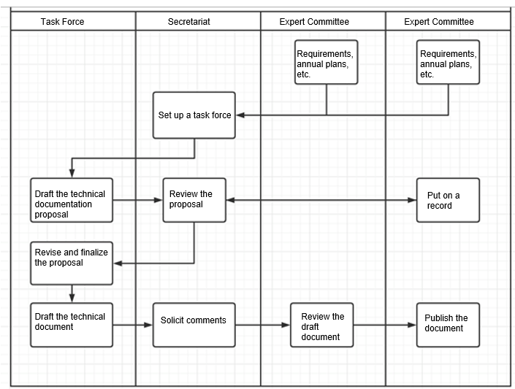

Annex 2

SparkLink Alliance Technical Documentation Project Proposal
Plan No.
Project Name
Target Audience | □ Internal | □ External
Responsible Member(s) | Name: |  | Planned Period
 | Contact Person:
 | Contact:
Participating Member(s)
Purpose and Significance
Scope and Technical Focus
Responsible Member(s)
(Signature or seal)
Date:

Annex 3

SparkLink Alliance Technical Document Draft Comments Summary

Project Name: Contact Person:
Drafted By: Phone No.:
Development Phase (Comment Soliciting or Reviewing): Date:
No. | Section No. | Comments | By | Response to Comments and Reasons

Annex 4

SparkLink Alliance Technical Document Review Form

Technical Document Name
Applicant
Review Method | □ Face-to-face joint review □ Correspondence review
Correspondence Review Time | Date when review comments are sent:  Deadline:
Review statistics:
- Number of reviewers:
- "Yes" votes:
- "No" votes:
- Abstention votes:
Comments:

Conclusion:

□ Pass
□ Reject (Suggestion: □ solicit comments again □ revise the document □ terminate the project)

Leader of the review team:

(Signature)

Date:
Members of the review team:
No. | Name | Company | Title

